**Project Definition:**

To make an AI Desktop Assistant that will assist the desktop user to perform operations ranging from basic to advanced, just by speaking.

**Outline**

1. Introduction ………………………………………….…………….

2. AI Components involved ……………………….……………

3. What can “HUGHIE” do? …………………………….………

4. Tools and Technologies used ………………………..…..

5. References - API/Plug-ins …………………………………..

6. Project Scope ………………………………………………………

**Introduction:**

* In daily life, it becomes very cumbersome to click or type to perform the basic operations like opening an application or performing search on web browser.
* To solve this problem, we can make use of an AI based desktop assistant. User does not have to perform the tasks manually, user just needs to give commands to perform tasks and this assistant will perform tasks by recognizing user’s voice from machine.
* An AI personal assistant is a piece of software that understands verbal commands and completes tasks assigned by the client.
* *A virtual assistant, also called an AI assistant or digital assistant, is an application program that understands natural language voice commands and completes tasks for the user.*
* Our AI assistant will interact with the user.
* This AI assistant will do the task which will be given by the user to perform.
* Our aim is to make the assistant perform every tasks which it can ranging from making a Google search to sending text messages and e-mails.
* We will try to make it as user-friendly as possible, so that users can use it and save a lot of time.

**AI components involved:**

* **Speech-to-text (STT)**- a voice processing component which takes user input in an audio format and produces a text representation of it.
* **NLU (Natural Language Understanding) -**a component which takes user input in text format and extract structured data (intents and entities) which helps assistant to understand what the user wants.
* **Dialogue management**-a component which determines how an assistant should respond at specific state of the conversation and generates that response in a text/audio format.
* **Text-to-speech (TTS)**- a component which takes the response of the assistant in a text format and produces a voice representation of it which is then sent back to the user.

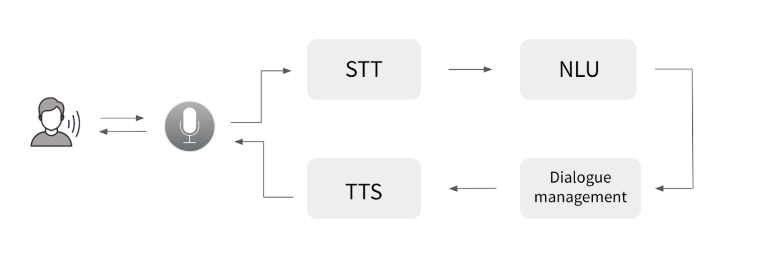

**What can “HUGHIE” do?**

* It can perform mathematical calculations from basic to advanced-level.
* It can give you answers regarding scientific, cultural and day-to-day life questions and many more questions.
* It can send an email from your account to any other e-mail user.
* It can give you detailed weather information about a specific city. The weather report includes information about the temperature, humidity, pressure, wind speed, sun-rise and sun-dusk time, etc. for that specific city.
* It can tell you a joke to make you laugh.
* It can interact with you.
* It can open websites like YouTube, Google and Stack-Overflow.
* It can play music.
* It can capture a photograph from the webcam.
* It can send a WhatsApp message to your friend.
* It will give you information about the various global stocks and their most recent prices, you just need to give a ticker symbol.
* You just need to provide a song name and it will open YouTube and start playing it.
* It can provide live cricket scores with an amazing accuracy.
* You can also get detailed information about the upcoming cricket matches and cricket players.
* It can perform various functions with the operating system such as ‘Shutdown’, ‘Sleep’, etc.

**Tools and technologies used:**

* Programming Language: Python
* Module/Packages:
* pyttsx3
* datetime
* speech_recognition
* suntime
* wikipedia
* webbrowser
* os
* cricapi
* pyjokes
* ecapture
* smtplib
* cv2
* numpy
* requests
* bs4
* wolframalpha
* pywhatkit

**References - API/Plug-ins:**

* OpenweatherMap API:

OpenweatherMap can give you the api to search weather information about any city.

Example: city is Delhi

It will give you temperature, humidity, wind speed and more information if you will ask to know.

API: [http://api.openweathermap.org/data/2.5/weather?appid=ap ikey&q=%27](http://api.openweathermap.org/data/2.5/weather?appid=ap%09ikey&q=%27)

* Wolfram-alpha:

Wolfram-alpha can answer to your query about mathematical questions, scientific & technical questions, general questions related with everyday life, historical questions, political questions and questions from other domains as well.

Example:

1. Math query: (x^2-1)/(x^2+1)

In answer, this graph will be given to user.

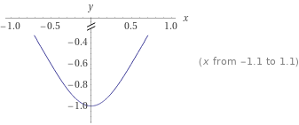

2. Query: How many baseballs fit in a Boeing 747?

In answer, the assistant will return:

4.8 million

Range of values: (4.5×10^6 to 5.1×10^6) (varies with packing density)

* Twelvedata Stock API:

This API provides access to all stock exchanges in the world, with a single API sharing the same format for all data.

Example:

If we enter IBM at the ticker symbol, then we get the following JSON response -

{'symbol': 'IBM', 'name': 'International Business Machines Corp', 'exchange': 'NYSE', 'currency': 'USD', 'datetime': '2021-04-30', 'open': '143.81000', 'high': '143.83000', 'low': '140.55000', 'close': '141.52000', 'volume': '5510683', 'previous_close': '144.24001', 'change': '-2.72000', 'percent_change': '-1.88575', 'average_volume': '6910407',

'fifty_two_week': {'low': '105.92000', 'high': '148.74001', 'low_change': '35.60001', 'high_change': '-7.22000', 'low_change_percent': '33.61028', 'high_change_percent': '-4.85411', 'range': '105.919998 - 148.740005'}}

* News API:

This API helps locate articles and breaking news headlines from news sources and blogs across the web with a JSON response.

Example: When we request for news related to a specific topic like ‘cricket’ then we get the response in the following format -

{'source': {'id': 'bbc-news', 'name': 'BBC News'}, 'author': None, 'title': 'Eight-year ban from cricket for ex-Zimbabwe captain Streak over corruption offences', 'description': 'Former Zimbabwe captain Heath Streak is banned from all cricket for eight years for corruption offences.', 'url': 'https://www.bbc.co.uk/sport/cricket/56712925', 'urlToImage': 'https://ichef.bbci.co.uk/live-experience/cps/624/cpsprodpb/3845/production/_118050441_heathstreak.jpg', 'publishedAt': '2021-04-14T11:08:12Z', 'content': 'Heath Streak played 65 Tests and 189 one-day internationals for Zimbabwe\r\nFormer Zimbabwe captain Heath Streak has been banned from all cricket for eight years for corruption offences.\r\nThe Internati… [+2033 chars]'}

Here, we get above JSON object in response and then we extract the important information to display the user.

* Cricapi:

This API provides live cricket scores, information about cricket players and upcoming matches which is most up-to-date.

Example:

When we fetch the batting stats of a particular cricketer in all the formats, then we get the following response –

Batting (T20) : Run = 2794 , Avg = 50.80

Batting (ODI) : Run = 11867 , Avg = 59.33

Batting (TEST) : Run = 7240 , Avg = 53.62

**Project Scope:**

* We’ll try to add text messaging feature.
* Try to do interesting things with the help of different API’s.
* We are looking to explore the areas like image processing and problem solving that may be incorporated to our project.
* We’ll try to invoke ‘HUGHIE’ on startup and activate it with a specific statement like ‘Hey, Hughie!’, ‘Help me, Hughie!’, ‘Okay Hughie’, etc.
* Make a user-friendly GUI that will take ‘HUGHIE’ to newer heights.
* Explore in the field of navigation using various APIs.
* We’ll try to sync contact numbers and e-mail id’s to our desktop assistant.